Project 2
This dashboard was created for Grazioso Salvare, a rescue-animal training company, to help identify the best dogs for search-and-rescue training. The app pulls data from a database of shelter animals and uses filters to find dogs based on rescue type, like water rescue, mountain rescue, or disaster tracking. Grazioso needed an easy and efficient way to locate specific dogs, and this dashboard provides everything they need in one place, including a data table, a pie chart, and a map.

Instructions for Running the App
Here’s how to run the app step-by-step:

Install Required Dependencies
Make sure Python is installed. Then, install the following libraries: pandas, dash, jupyter-dash, dash-leaflet, pymongo, and plotly. These libraries are needed to run the dashboard and connect to the database.

Set Up MongoDB and Load the Data
Install MongoDB and ensure it is running. Load the provided shelter data into a MongoDB collection using MongoDB Compass or the Mongo Shell.

Run the Jupyter Notebook Dashboard
Open Jupyter Notebook and load the ProjectTwoDashboard.ipynb file. Run the notebook to start the dashboard, which will open in a web browser.

Tools Used and Rationale
MongoDB
Why It Was Used: MongoDB is ideal for handling flexible, unstructured data like the shelter database. It’s scalable, fast, and integrates well with Python.

Dash Framework
Why It Was Used: Dash allows the creation of interactive web apps with Python. It’s useful for building features like data tables, charts, and maps that update dynamically based on user input.

Screenshots or Screencast
The screenshots included show how the dashboard looks and works:

Starting State: Displays the unfiltered data table, pie chart, and map.
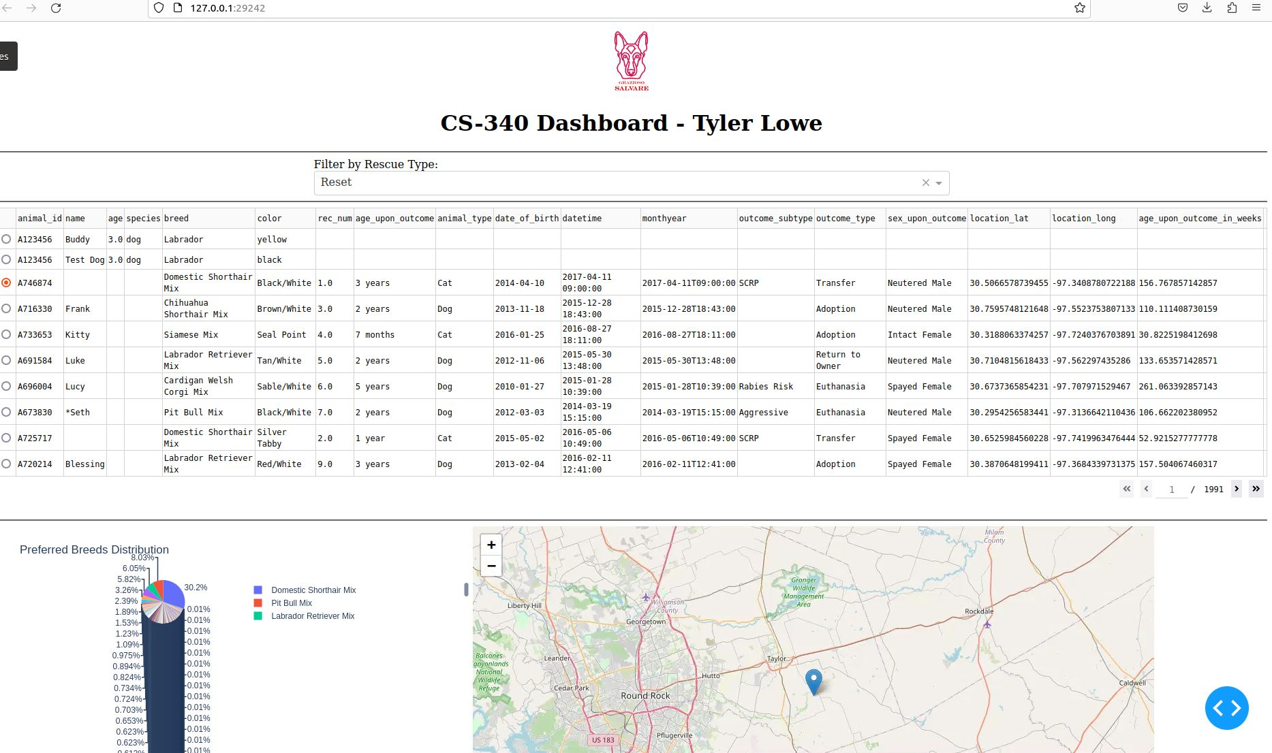
Water Rescue Filter: Filters for breeds like Labrador Retrievers.
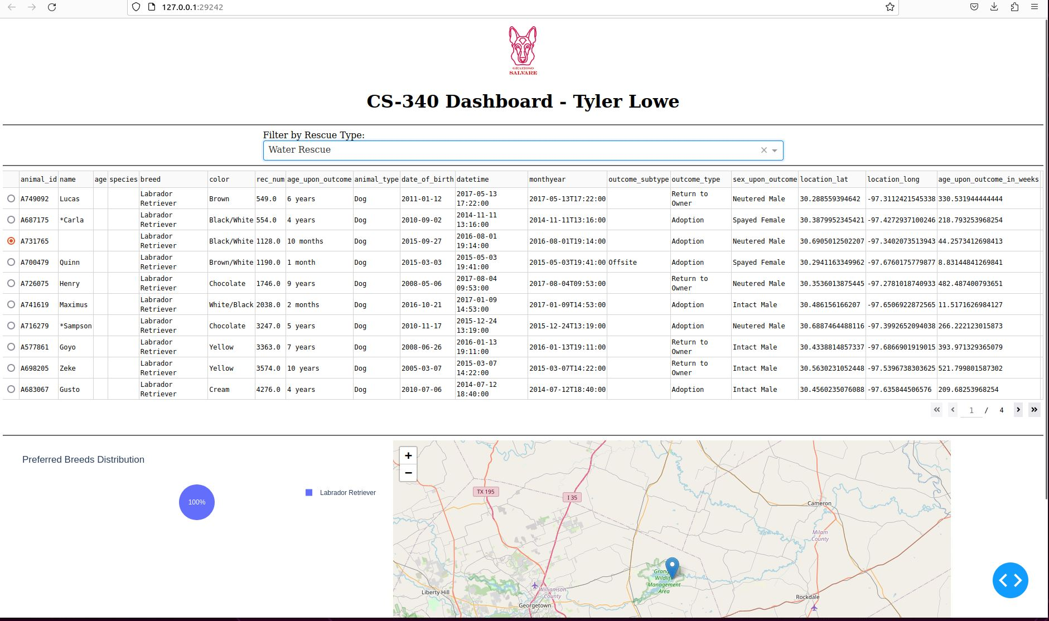
Mountain or Wilderness Rescue Filter: Filters for breeds like German Shepherds.
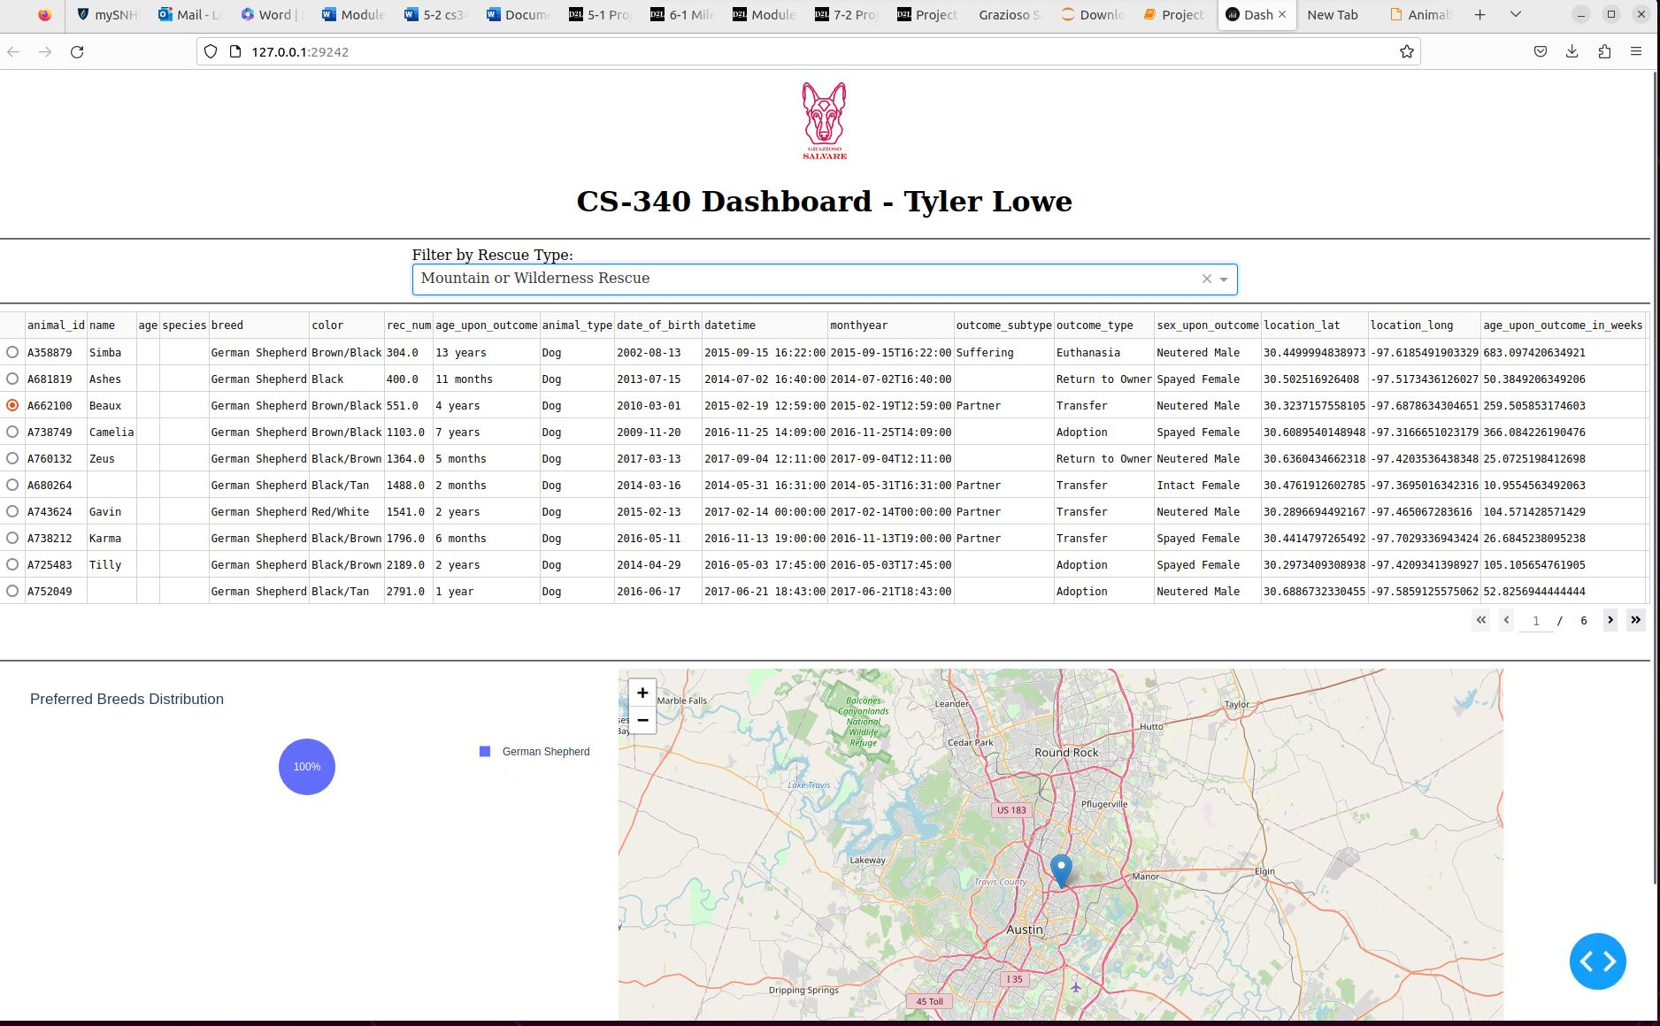
Disaster or Individual Tracking Filter: Filters for breeds like Beagles.
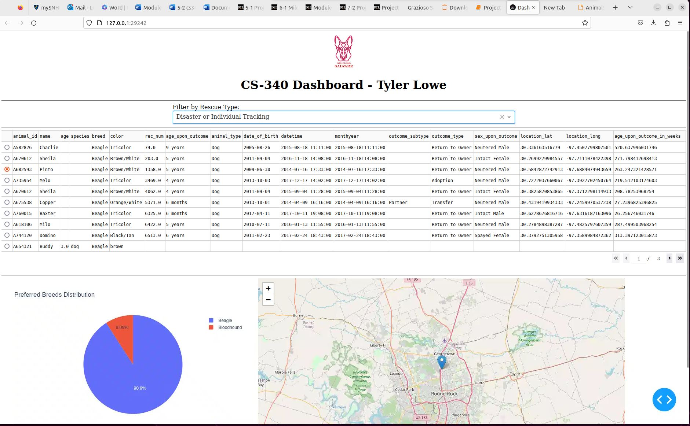
Reset Filter: Resets the dashboard to display all data again.
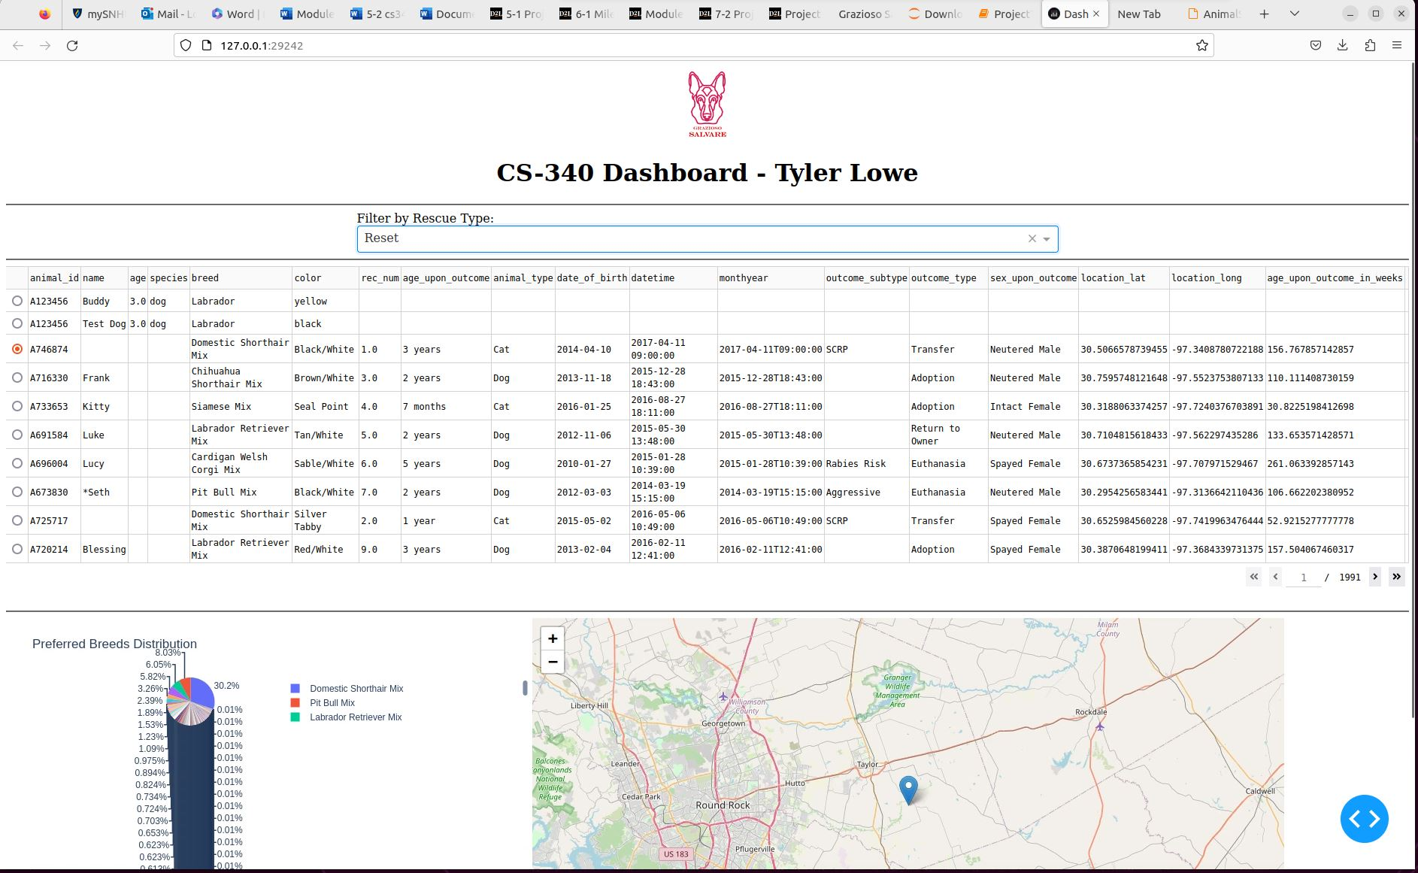
Challenges and Solutions
Challenge: Handling Missing Data
Some fields in the dataset were incomplete or missing, causing issues.
Solution: Missing values were replaced with empty strings to prevent errors.

Challenge: Map Rendering Issues
The map wouldn’t display correctly because some location values weren’t numbers.
Solution: All data types were converted to strings, and default coordinates were added for missing location data.

Challenge: Connecting Filters to Charts
It was challenging to ensure the pie chart and map updated correctly when filters were applied.
Solution: Dash callbacks were used to link the filters, data table, pie chart, and map.

